Data Storage Web Service Specification
Version: | 0.1
Author(s): | AT, JE, RR
Created: | 02/17/2009
Last modification: | 03/02/2009

Version | Date | Author(s) | Changes
0.1  0.2  0.3  0.4 | 02/17/2009  02/26/2009  02/27/2009  03/02/2009 | AT, JE, RR  AT, JE, RR  AT  AT | Initial version.  Revised version.  Revised version.  Revised version.
Contents
1. Introduction 2
1.1. References 2
1.2. Product Scope 3
2. Overall Description 4
2.1. Design and Implementation Constraints 4
2.2. Communication 4
2.3. Protocols 4
3. Introduction to web service features 5
3.1. Actor 5
3.2. Accessibility 5
4. Use Cases 6
4.1. Create File Reference 6
4.2. Load File Reference 6
4.3. Remove File Reference 7
4.4. Check if URI is accessible 8
5. Nonfunctional Requirements 9
5.1. File Size 9
5.2. Distribution 9
5.3. Further requirements 9

Introduction
This document provides a clear and structured collection of functional and non-functional requirements for the Data Storage web service. This document refers to the main specification and extends the main specification concerning the web services used inside the “DecidR” application.

References
Code | Description
[spec] | Title:  Software Requirements Specification  Author:  Markus Fischer, Daniel Huss, Jonas Schlaak, Modood Alvi  Source:  https://code.google.com/p/decidr/source/browse/trunk/docs/specification/Software%20Requirements%20Specification.doc  Revision:  419
[cdict] | Title:  Glossary  Author:  Markus Fischer, Daniel Huss  Source:  https://decidr.googlecode.com/svn/trunk/docs/specification/Glossary.doc  Revision:  419
[email] | Title:  WS Email Specification  Author:  Reinhold Rumberger  Source:  https://code.google.com/p/decidr/source/browse/trunk/docs/specification/WS%20Email%20Specification.doc  Revision:  419
[htspec] | Title:  WS Human Task Specification  Author:  Johannes Engelhardt  Source:  https://code.google.com/p/decidr/source/browse/trunk/docs/specification/WS%20Human%20Task%20Specification.doc  Revision:  419

Product Scope
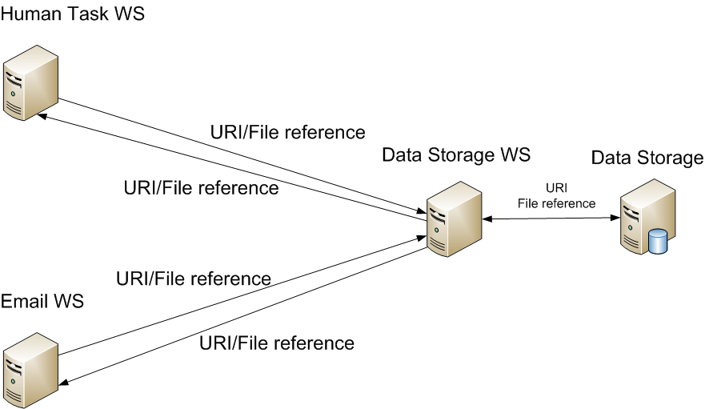
Web services are main components in the service-oriented architecture (SOA). A web service is identified by its URI and provides several operations on his interface defined by the URI. It is needed for automatic communication within an application. The Data Storage web service provides operations for the “DecidR” application for saving, loading and removing files in a database. These files are not accessible for users directly. Only the Email and the Human Task web service can access the Data Storage web service. For example, if an email has attachments these are taken from the data storage. Or if a human task is created and a user has to upload some files. These files are stored in the database via the Data Storage web service.

Overall Description
In this section only requirements for the Data Storage web service are specified. For further information how the “DecidR” application works look up the main specification [spec].

Design and Implementation Constraints
This section describes the issues that will limit the options available to the developers during the design and implementation phases.

Communication
The Data Storage web service communicates with the Email and Human Task web service via SOAP. The data stored in the database isn't sent through SOAP to the Human Task and Email web service. Only a file reference is given to them.

Protocols

Introduction to web service features

Actor
In this specification the actors aren't persons because the web service communicates within the system with other components. And no direct human interaction is needed. The actors for the Data Storage web service are the workflow instances or other web services. Workflow instances are generated from workflow models by the workflow admin. Other web services are the Email and Human Task web service and new web services which will be added in the future.

Accessibility
For all use cases the database must be accessible (global precondition). For the case that the database isn't accessible (global alternative flow) a “database not accessible” exception is thrown (global alternative post condition).

Use Cases
Actor | A workflow instance or another web service.
Global precondition | The database is accessible.
Global alternative flow | - The database is not accessible.  - The WS throws a “database not accessible” exception.
Global alternative post condition | The database is not accessible.

Create File Reference
Goal | A new file reference is to be stored in the database.
Precondition | None
Basic flow | - The actor passes a URI.  - The WS confirms the existence of the file specified by the URI.  - The WS generates a new file reference and stores the URI and the reference in the database.  - The WS returns the file reference to the actor.
Post condition | The database contains an entry consisting of the generated file reference and the passed URI. The file specified by the URI is accessible.
Alternative flow | 1a. The URI is invalid.  2a. The WS throws a “URI invalid” exception.
Alternative post condition | The database isn’t modified by the WS.
Alternative flow (2) | 2b. The file specified by the URI couldn’t be accessed.  3b. The WS throws a “file not found” exception.
Alternative post condition (2) | The database isn’t modified by the WS.

Load File Reference
Goal | A URI is to be retrieved from the database.
Precondition | None
Basic flow | - The actor passes a file reference.  - The WS confirms the existence and validity of the syntax of the file reference in the database.  - The WS retrieves the URI associated with the file reference from the database.  - The WS confirms the existence of the file specified by the URI.  - The WS returns the URI to the actor.
Post condition | The database contains an entry consisting of the generated file reference and the passed URI. The file specified by the URI is accessible.
Alternative flow | 2a. The syntax of the file reference is invalid.  3a. The WS throws an “invalid file reference syntax” exception.
Alternative post condition | The database doesn’t contain an entry with the passed file reference. The database isn’t modified by the WS.
Alternative flow (2) | 2b. The file reference doesn’t exist in the database.  3b. The WS throws a “file reference not found” exception.
Alternative post condition (2) | The database doesn’t contain an entry with the passed file reference. The database isn’t modified by the WS.
Alternative flow (3) | 4c. The file specified by the URI couldn’t be accessed.  5c. The WS throws a “file not found” exception.
Alternative post condition (3) | The database doesn’t contain an entry with the passed file reference. The database isn’t modified by the WS. The file specified by the URI is not accessible.

Remove File Reference
Goal | A file reference is to be removed from the database.
Precondition | None
Basic flow | - The actor passes a file reference.  - The WS confirms the existence and validity of the syntax of the file reference in the database.  - The WS removes the file reference from the database.
Post condition | The file reference is removed from the database.
Alternative flow | 2a. The syntax of the file reference is invalid.  3a. The WS throws an “invalid file reference syntax” exception.
Alternative post condition | The database doesn’t contain an entry with the passed file reference. The database isn’t modified by the WS.
Alternative flow (2) | 2b. The file reference doesn’t exist in the database.  3b. The WS throws a “file reference not found” exception.
Alternative post condition (2) | The database doesn’t contain an entry with the passed file reference. The database isn’t modified by the WS.

Check if URI is accessible
Goal | The accessibility of URI is to be confirmed.
Precondition | None
Basic flow | - The actor passes a URI.  - The WS confirms the existence of the file specified by the URI.  - The WS returns “true”.
Post condition | The file specified by the URI is accessible.
Alternative flow | 2b. The file specified by the URI couldn’t be accessed.  3b. The WS returns “false”.
Alternative post condition | The database isn’t modified by the WS.

Nonfunctional Requirements

File Size
E-Mail attachments and human task activity uploads are limited to 5 megabyte (MB) per file.

Distribution
A centralized data storage is sufficient. However, it should be possible to configure the location of the data storage because of separate usage for different “DecidR” applications.

Further requirements
Further requirements like changeability, availability, portability, testability and robustness are specified in the main specification and are valid for the Data Storage web service specification, too.

